**SQL Server IP and TCP Port Details**

<https://www.ourtechideas.com/blog/find-ip-and-port/>

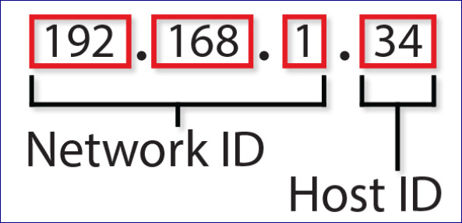

**Run any one of the below TSQL Statement to fetch SQL Server IP and TCP Port Details.**

select

@@servername as [Server Name],

@@servicename as [Instance Name],

client_net_address as [Client Machine IP],

local_net_address as [SQL Server IP],

local_tcp_port as [SQL Server Port],

auth_scheme as [Authentication Mode],

net_transport as [Physical Transport Portocol],

protocol_type as [Payload Portocol Type]

FROM sys.dm_exec_connections

where session_id=@@SPID

go

SELECT

@@servername as [Server Name],

@@servicename as [Instance Name],

CONNECTIONPROPERTY('client_net_address') AS [Client Machine IP],

CONNECTIONPROPERTY('local_net_address') AS [SQL Server IP],

CONNECTIONPROPERTY('local_tcp_port') AS [SQL Server Port],

CONNECTIONPROPERTY('auth_scheme') AS [Authentication Mode],

CONNECTIONPROPERTY('net_transport') AS [Physical Transport Portocol],

CONNECTIONPROPERTY('protocol_type') AS [Payload Portocal Type]

